**A**

**Project Report on**

**DEVELOPING A MACHINE LEARNING-BASED TOOL FOR IDENTIFYING PLANT DISEASES**

**Submitted to the partial fulfillment of the requirement for the award of the degree of**

**BACHELOR OF TECHNOLOGY**

**IN**

**COMPUTER SCIENCE & ENGINEERING**

**Submitted by:**

**Aditya Bhardwaj (RA1911003030190)**

**Yash Singhwal (RA1911003030197)**

**Deepanshu (RA1911003030204)**

**Paras Rajpal (RA1911003030238)**

**Project ID: 23MP0144**

**Supervised by:**

**Dr. Chandra Shekhar Tyagi**

**Assistant Professor**



**SRM Institute of Science and Technology**

**Delhi NCR Campus, Modi Nagar,**

**Ghaziabad (UP)-201204**

**2023**

**BONAFIDE CERTIFICATE**

This is to certify that project Report entitled “**Developing a Machine Learning-Based Tool For Identifying Plant Diseases**”, which is submitted by Aditya Bhardwaj (RA1911003030190), Yash Singhwal (RA1911003030197), Deepanshu (RA1911003030204) and Paras Rajpal (RA1911003030238) in the partial fulfillment of the requirement for the award of degree B.Tech (CSE) of SRM Institute of Science and Technology, Delhi-NCR Campus, Modi Nagar, Ghaziabad is a record of the candidate own work carried out by them under my own supervision.

…………………………………. ………………………………….

(Signature) (Signature)

Dr. Chandra Shekhar Tyagi Dr. Akash Punhani

Supervisor Head of Department

Assistant Professor (Computer Science and Engineering)

INTERNAL EXAMINER EXTERNAL EXAMINER

**ACKN****OWLEDGEMENT**

We would also like to express our special thanks to Mr. Chandra Shekhar Tyagi, Assistant Professor and Project Supervisor of SRM Institute of Science and Technology, Delhi-NCR Campus, Modi Nagar, for his insight and knowledge on the subject, who imbued us with the feeling to work assiduously.

We feel compelled to articulate our thankfulness to Dr. Jitendra Singh, and Dr. Rakesh Kumar Yadav, Project Coordinators, SRM Institute of Science and Technology, Delhi-NCR Campus, Modi Nagar, for there enlightening dexterity which was truly a perennial source of inspiration.

We would like to express our hearty gratitude to respected Director, Dr. S. Vishwanathan, SRM Institute of Science and Technology, Delhi-NCR Campus, Modi Nagar, under whose auspices we were able to work on our project work.

We would like to express our hearty gratitude to Dr. D. K. Sharma, Dean, SRM Institute of Science and Technology, Delhi-NCR Campus, Modi Nagar, under whose auspices we were able to work on our project work.

Also, we extend our sincere regards and thanks to Dr. Akash Punhani, Head of the Department, Computer Science and Engineering, & Dean Admission, SRM Institute of Science and Technology, Delhi-NCR Campus, Modi Nagar, for his suggestions.

We are also indebted to all the teaching and non-teaching staff members of our college for helping us directly or indirectly by all means throughout the course of our study and project work.

Finally, we take this opportunity to thank our parents, family members and friends for their moral support and help and extended thanks to our well-wishers.

Aditya Bhardwaj (RA1911003030190)

Yash Singhwal (RA1911003030197)

Deepanshu (RA1911003030204)

Paras Rajpal (RA1911003030238)

**DECLARATION**

We, Aditya Bhardwaj (RA1911003030190), Yash Singhwal (RA1911003030197), Deepanshu (RA1911003030204) and Paras Rajpal (RA1911003030238) hereby declare that the work which is being presented in the project report “**Developing a Machine Learning-Based Tool for Identifying Plant Disease**” is the record of authentic work carried out by us during the period from January’23 to May’23 and submitted by us in partial fulfillment for the award of the degree “Bachelor of Technology in Computer Science and Engineering” to SRM IST, NCR Campus, Ghaziabad (U.P.). This work has not been submitted to any other University or Institute for the award of any Degree/Diploma.

Aditya Bhardwaj (RA1911003030190)

Yash Singhwal (RA1911003030197)

Deepanshu (RA1911003030204)

Paras Rajpal (RA1911003030238)

**ABSTRA****CT**

The goal of our project is to develop a machine learning model that can identify and classify plant diseases using image classification techniques. Our objective is to address the timely and accurate detection of plant diseases, which can significantly impact crop yields and food security.

Our project’s objectives include training a model capable of accurately recognizing different types of plant diseases from images and creating a user-friendly interface for farmers and agricultural professionals to use in the field. We will use a dataset of images of both healthy and diseased plants to train our model. We will employ deep learning techniques, particularly convolutional neural networks, to classify the images and identify the presence of disease. The model will be trained and evaluated using transfer learning, data augmentation, and k-fold cross-validation methods.

We anticipate that our machine learning model will have a high degree of accuracy in detecting plant diseases and will generalize well to new im- ages. Additionally, we expect that the user-friendly interface will make the model practical and accessible for farmers and agricultural professionals.

**TABLE OF CONTENTS**

**ACKNOWLEDGEMENTS iii**

**ABSTRACT v**

**LIST OF FIGURES vii**

**ABBREVIATIONS viii**

**1. INTRODUCTION ix**

**2. LITERATURE SURVEY xi**

**3. EXISTING PROBLEM AND PROPOSED SOLUTION xviii**

**4. ARCHITECTURAL DESIGNS OF THE PROPOSED SYSTEM x****x**

**5. DATASET/ DATABASE SPECIFICATION xxii**

**6. METHODOLOGIES xx****iv**

**7. FINAL IMPLEMENTATION xxxi**

7.0.1 Code Snippets .............................................................................................. xxxi

7.0.2 Important Links ....................................................................................... xxxviii

**8. EXPECTED OUTCOMES xxxix**

**9. CONCLUSIONS xliii**

**10. FUTURE WORK xl****iv**

**11. REFERENCES xlv**

**LIST OF FIGURES**

* 1. Different Phases of crop disease detection .................................................................. x
  2. Architectural Design .................................................................................................. xx
  3. Images of Healthy Potato ....................................................................................... xxiii
  4. Images of Early blight Potato ................................................................................. xxiii
  5. Images of Late blight Potato .................................................................................. xxiii
  6. Machine Learning ................................................................................................... xxiv
  7. Deep Learning .......................................................................................................... xxv
  8. Convolutional Neural Network ............................................................................... xxvi
  9. Sequential Model ................................................................................................... xxvii
  10. TensorFlow ........................................................................................................... xxviii
  11. Image Processing .................................................................................................... xxix
  12. ReactJS ..................................................................................................................... xxx

**ABBREVIATIONS**

IHME Institute of Health Metrics and Evaluation

SVM Support Vector Machine

RFA Random Forest Algorithm

LRA Linear Regression Algorithm

KNN k-Nearest Neighbors

DD Dependency Diagram

PC Problem Conceptualization

ML Machine Learning

ROS Realization of Solution

MI Method Identification

**CHAPTER - 1**

**INTRODUCTION**

The detection of plant diseases is critical in ensuring the health and productivity of crops. Automatic techniques for detecting plant diseases have become increasingly important in monitoring large farms and alerting producers to the appearance of diseases on plant leaves. Ensuring timely and precise detection of plant diseases is of utmost importance, particularly considering the growing global population and the necessity to cultivate sufficient crops to sustain the world's food needs.

Unfortunately, plants can be affected by various diseases that cause a significant loss in productivity. These diseases can result in decreased yield, poor quality crops, and an increased risk of contamination. Plant diseases can also spread quickly and affect large areas of crops, leading to devastating consequences for farmers and the food supply.

To address these challenges, we can leverage a combination of technologies such as artificial intelligence, machine learning and convolutional neural networks (CNN). By employing these cutting-edge technologies, we can enhance our capabilities in combating these issues effectively. By implementing advanced techniques, we can provide smarter solutions for detecting and identifying plant diseases.

Plant disease detection falls under the category of predictive modelling, where the goal is to predict a class label for a given input data sample. In this case, the output of the model will be binary, indicating either "yes" or "no" to signify whether the plant is diseased or healthy, respectively.

The application of artificial intelligence and machine learning techniques in plant disease detection has proven to be highly effective. By training machine learning models on large datasets containing images of healthy and diseased plants, these models can learn to recognize and distinguish the visual patterns associated with different types of plant diseases.

Convolutional neural networks (CNNs) have become widely used and highly effective in the field of plant disease detection. This deep learning technique excels at extracting significant image features and using them for accurate classification. The training process involves exposing the networks to extensive collections of images, enabling them to learn and generalize from the data. As a result, the trained models demonstrate impressive accuracy when classifying new images.

Our project aims to create an accurate machine learning model for identifying and classifying plant diseases using image classification techniques. We also aim to develop a user-friendly interface for easy field identification of diseased plants.

In conclusion, the detection of plant diseases is essential for ensuring the health and productivity of crops, and automatic techniques can greatly assist in this process. By utilizing advanced technologies, we can develop smarter solutions for detecting and identifying plant diseases. With the increasing global population and the need to grow enough crops to feed the world, it is more important than ever to develop effective and efficient methods for monitoring and maintaining the health of crops.

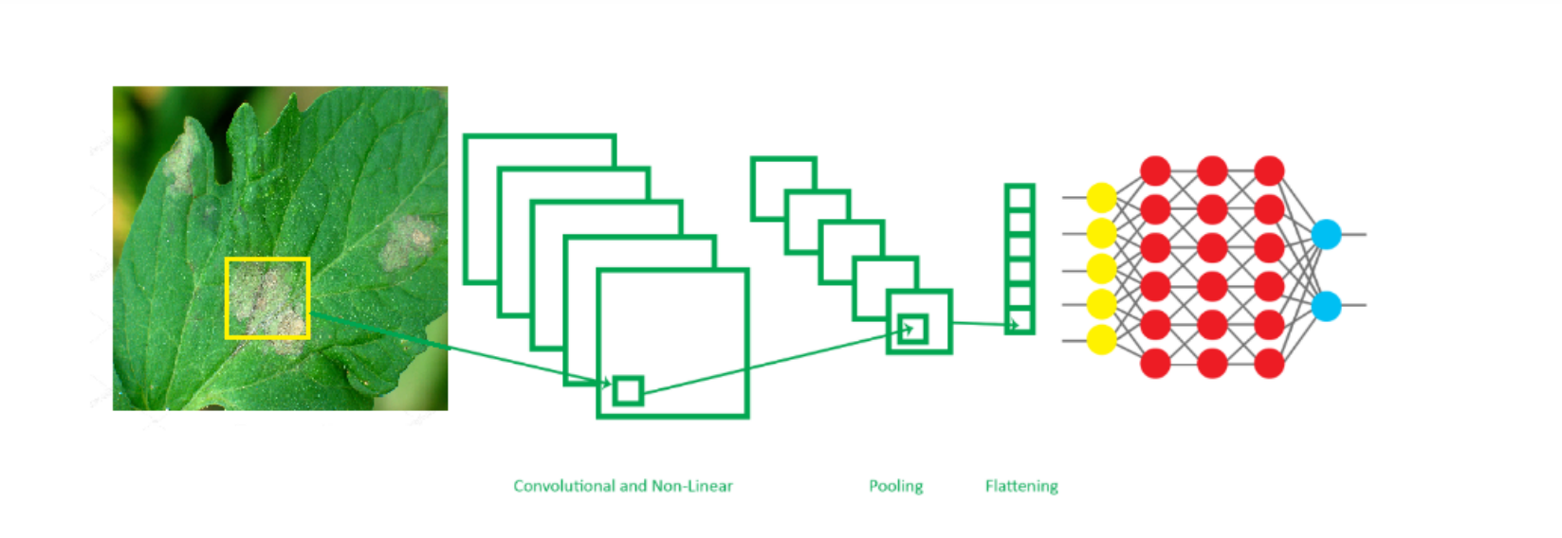

**Figure 1.1:** Different Phases of crop disease detection.

**CHAPTER – 2**

**LITERATURE SURVEY**

|  |  |  |
| --- | --- | --- |
| **Paper and Author** | **Methodology** | **Conclusion** |
| “Detection of Leaf Disease and Classification Using Digital Image Processing” (2012) by RM Prakash | Support vector machines (SVMs) and k-means clustering | When differentiating between different plant diseases, the suggested method attained a notable accuracy rate of 92.2%. |
| “Applying Image Processing Techniques to Detect Plant Diseases” (2012) by Kulkarni et al | Artificial neural networks (ANNs) | The proposed technique exhibited a detection accuracy of 91% when identifying plant diseases. |
| “Detection of Unhealthy Region of Plant Leaves and Classification of Plant Leaf Diseases Using Texture Features” (2013) by Arivazhagan Selvaraj | Color transformation, classification, and segmentation | With an accuracy of 90%, the proposed method successfully identified unhealthy regions on plant leaves. |
| “Leaf Disease Detection and Classification Using Artificial Neural Network” (2015) by Malavika Ranjan, Manasi Rajiv Weginwar, and A. Ingole. | Artificial neural networks (ANNs) | ANNs were trained to distinguish diseased plants from healthy samples by learning a set of features that were carefully chosen. Model successfully achieved an accuracy of 85%. |

|  |  |  |
| --- | --- | --- |
| **Paper and Author** | **Methodology** | **Conclusion** |
| “Deep Learning for Image-based Plant Detection” (2016) by Sharada P. Mohanty and David P. Hughes. | Convolutional Neural Network (CNNs) | The model underwent training to differentiate between healthy and diseased plants across fourteen distinct species, achieving an exceptional accuracy of 99% on the test set. Although this performance exceeds random selection, incorporating a broader range of training data can lead to further improvements in accuracy. |
| “Cucumber Disease Detection Using Artificial Neural Network” (2016) by P. Pawar | Artificial neural networks (ANNs) | The utilization of supplementary texture features can enhance the classification accuracy. |
| “Detection and Measurement of Paddy Leaf Disease Symptoms Using Image Processing” (2017) by RP Narmadha | Artificial neural networks (ANNs) | The study assesses multiple image processing techniques used in the detection and diagnosis of crop leaf diseases. |
| “Convolutional Neural Network-based Inception v3 Model for Animal Classification” (2020) by Jyotsna Bankar | Convolutional Neural Network (CNNs) | The model is not only useful for object classification but also for categorization, rendering it an asset in diverse image classification tasks. |
| “Plant Disease Detection Using CNN and GAN” (2022) by Emanuel Cortes | Convolutional Neural Networks (CNNs) and Generative Adversarial Networks (GANs) | Accurate feature extraction and output mapping heavily rely on background segmentation, which plays a critical role in various applications. Intriguingly, the utilization of Generative Adversarial Networks (GANs) demonstrates promising prospects in disease classification for plants. |

|  |  |  |
| --- | --- | --- |
| **Paper and Author** | **Methodology** | **Conclusion** |
| “A Survey on Image-Based Plant Disease Detection and Diagnosis” (2018) by Zhang et al | Deep learning and Image processing. | The researchers provide a comprehensive analysis of the detection and diagnosis of plant diseases using image-based methods. They discuss a wide range of image processing techniques and machine learning algorithms employed in this domain. Furthermore, they emphasize the existing obstacles that need to be overcome to improve the precision and dependability of plant disease detection and diagnosis through image analysis. |
| **“Deep Learning for Plant Disease Detection and Diagnosis: A Review” (2019)** by Liu et al | Deep learning | The researchers conduct a comprehensive analysis of the recent advancements in utilizing deep learning techniques to detect and diagnose plant diseases. They explore diverse deep learning architectures employed for this purpose and discuss the datasets used for training and evaluating these models. Additionally, they address the existing challenges that demand attention to enhance the accuracy and reliability of deep learning-based plant disease detection and diagnosis. |
| **“A Survey on the Use of Remote Sensing for Plant Disease Detection and Diagnosis” (2021) by Zhang et al** | Remote Sensing | The authors present an extensive and detailed overview of the current state-of-the-art in utilizing remote sensing techniques for the purpose of detecting and diagnosing plant diseases. They discuss the different remote sensing techniques that have been used for this task. |

**2.0.1 Summary**

1. **"Detection of Leaf Disease and Classification Using Digital Image Processing"** (2012) by RM Prakash: The paper proposes a methodology utilizing Support Vector Machines (SVMs) and k-means algorithm to classify and detect plant diseases. The approach achieved an impressive classification accuracy of 92.2% when distinguishing various plant diseases.

2. **"Applying Image Processing Techniques to Detect Plant Diseases"** (2012) by Kulkarni et al: The paper introduces a technique employing Artificial Neural Networks (ANNs) for the detection of plant diseases. The proposed method exhibited a detection accuracy of 91% when identifying plant diseases.

3. **"Detection of Unhealthy Region of Plant Leaves and Classification of Plant Leaf Diseases Using Texture Features"** (2013) by Arivazhagan Selvaraj: The paper presents a methodology involving color transformation, segmentation, and classification for detecting unhealthy regions on plant leaves. The proposed method achieved an accuracy of 90% in identifying these regions.

4. **"Leaf Disease Detection and Classification Using Artificial Neural Network"** (2015) by Malavika Ranjan, Manasi Rajiv Weginwar, and A. Ingole: The study primarily centers around employing Artificial Neural Networks (ANNs) to differentiate between plants that are healthy and those affected by diseases. The trained ANNs achieved an accuracy of 85% by learning a set of carefully chosen features.

5. **"Deep Learning for Image-based Plant Detection"** (2016) by Sharada P. Mohanty and David P. Hughes: The paper employs Convolutional Neural Networks (CNNs) to differentiate between healthy and diseased plants across various species. The model achieved an exceptional accuracy of 99% on the test set, emphasizing the potential for further improvement by incorporating a broader range of training data.

6. **"Cucumber Disease Detection Using Artificial Neural Network"** (2016) by P. Pawar: The paper discusses the utilization of Artificial Neural Networks (ANNs) for detecting cucumber diseases, highlighting the potential enhancement in classification accuracy through the incorporation of supplementary texture features.

7. **"Detection and Measurement of Paddy Leaf Disease Symptoms Using Image Processing"** (2017) by RP Narmadha: The paper explores multiple image processing techniques for the detection and diagnosis of crop leaf diseases, specifically focusing on paddy leaves.

8. **"Convolutional Neural Network-based Inception v3 Model for Animal Classification"** (2020) by Jyotsna Bankar: The paper introduces a Convolutional Neural Network (CNN)-based model that goes beyond object classification to encompass categorization, proving its usefulness in diverse image classification tasks.

9. **"Plant Disease Detection Using CNN and GAN"** (2022) by Emanuel Cortes: The paper proposes the utilization of Convolutional Neural Networks (CNNs) and Generative Adversarial Networks (GANs) for accurate feature extraction and output mapping in plant disease classification. The study highlights the promising prospects of GANs in disease classification for plants, particularly with background segmentation.

10. **"A Survey on Image-Based Plant Disease Detection and Diagnosis"** (2018) by Zhang et al: The paper presents an extensive and meticulous examination of image-based approaches for the detection and diagnosis of plant diseases. It encompasses a diverse array of techniques and methodologies. The authors emphasize the remaining challenges that need to be addressed to enhance accuracy and reliability in this field.

11. **"Deep Learning for Plant Disease Detection and Diagnosis: A Review"** (2019) by Liu et al: The paper conducts a detailed analysis of the recent advancements in deep learning techniques for the detection and diagnosis of plant diseases. It explores various deep learning architectures implemented in this field and assesses the datasets used for training and evaluation. Additionally, the paper addresses the current challenges involved in enhancing the accuracy and reliability of plant disease detection and diagnosis using deep learning approaches.

12. **"A Survey on the Use of Remote Sensing for Plant Disease Detection and Diagnosis"** (2021) by Zhang et al: This paper offers a comprehensive and in-depth overview of the latest advancements in employing remote sensing techniques for the detection and diagnosis of plant diseases. It examines various remote sensing techniques used for this purpose, along with some algorithms that have been developed. The authors also highlight the prevailing challenges that must be addressed to improve the precision and dependability of plant disease detection and diagnosis through remote sensing methods.

In summary, these papers contribute to the field of plant disease detection and diagnosis by proposing various methodologies and techniques. They utilize different approaches such as support vector machines (SVMs), k-means clustering, artificial neural networks (ANNs), color transformation, segmentation, and deep learning architectures. The results presented in these papers demonstrate impressive classification accuracies ranging from 85% to 99% when distinguishing between healthy and diseased plants or identifying specific plant diseases.

These studies underline the importance of advancing technology in agriculture and highlight the potential of image processing, machine learning, and deep learning techniques in improving the accuracy and efficiency of plant disease detection and diagnosis. However, they also acknowledge the existing challenges that need to be addressed, such as incorporating larger and more diverse datasets, overcoming issues related to feature extraction and mapping, and ensuring robustness and reliability in real-world scenarios.

Overall, these papers provide valuable insights and directions for further research and development in the field of plant disease detection and diagnosis, aiming to mitigate the impact of diseases on crop productivity, reduce financial losses for farmers, and contribute to global food security.

**CHAPTER 3**

**EXISTING PROBLEM AND PROPOSED SOLUTION**

The agricultural industry has been characterized by a slower pace of adopting advanced technologies compared to other sectors, leading to a multitude of inefficiencies and challenges for farmers. One of the most critical challenges they face is the timely and accurate detection of plant diseases. Failure to promptly identify diseases can have far-reaching consequences, including diminished crop productivity, substantial financial losses, and even potential food shortages for the ever-growing global population.

To address this pressing issue, we propose an innovative solution that leverages the power of machine learning algorithms to identify and classify plant diseases based on captured images of plant leaves. Our approach aims to provide farmers with a comprehensive resolution by potentially incorporating a medicinal section for treatment, provided adequate time and resources are available.

At the core of our solution lies the utilization of cutting-edge deep learning techniques, particularly convolutional neural networks (CNNs). These neural networks excel at image recognition tasks and have demonstrated remarkable capabilities in various domains, including healthcare and agriculture. By training a CNN model on an extensive dataset of plant images, encompassing both healthy and diseased plants, we can educate the algorithm to accurately discern between different types of diseases, enabling precise and reliable disease identification.

To ensure accessibility and user-friendliness for farmers, our plan involves the development of a web application using modern technologies such as React and FastAPI. This web application will serve as an intuitive and seamless interface, empowering farmers to effortlessly upload images of diseased plants and receive accurate diagnoses. Additionally, the application will provide clear and concise information about the identified diseases, potentially offering recommended treatments or management practices to assist farmers in effectively combating the diseases.

By harnessing the potential of artificial intelligence (AI), machine learning (ML), CNNs, and deep learning, our solution aims to revolutionize the detection and treatment of diseases. The integration of advanced technologies enables faster and more accurate disease identification, empowering farmers to take prompt actions to safeguard their crops. This, in turn, leads to increased crop productivity, minimized losses, and improved overall agricultural sustainability.

Recognizing the significance of accessibility for farmers with diverse technological literacy levels, we prioritize designing a user interface that is intuitive, user-friendly, and accessible. The aim is to create an environment where farmers, regardless of their technical expertise, can easily navigate the web application and leverage its capabilities to detect and treat plant diseases effectively. This approach not only empowers individual farmers but also promotes the adoption of advanced technologies in the agricultural industry.

In summary, our proposed solution presents a promising approach to address the persistent challenge of plant diseases faced by farmers. By amalgamating advanced technologies such as AI, ML, CNNs, and deep learning with a user-friendly web application, we aim to equip farmers with an efficient and effective tool for detecting and treating plant diseases. Through this innovative endeavor, we strive to contribute to the progress of the agricultural industry, supporting farmers in their mission to ensure food security for the growing global population. By leveraging the power of technology, we envision a future where farmers can detect and combat plant diseases swiftly and effectively, resulting in increased crop yields, enhanced sustainability, and a more resilient agricultural ecosystem.

**CHAPTER – 4**

**ARCHITECTURAL DESIGN OF THE PROPOSED SOLUTION**

1. Image Capture and Processing:
   * The first step in our proposed solution is to capture digital images of plant leaves, which will be used for disease detection. The images will then be processed to prepare them for analysis.
2. Feature Extraction:
   * Next, we will extract relevant features from the processed images, using exploratory data analysis (EDA) techniques to identify patterns and characteristics.
3. Dataset Division:
   * The dataset will be divided into 2 halves: a training and validation set (80 percent) and a test set (20 percent). This division will allow us to train and evaluate our machine learning model effectively.
4. Model Training and Validation:
   * We will utilize a combination of algorithms, to create a machine learning model capable of accurately detecting plant diseases. To ensure its effectiveness, the model will undergo training and validation using dedicated datasets. We will leverage transfer learning and data augmentation techniques to enhance its performance.
5. Display and Comparison of Results:
   * Once the model is trained and validated, we will display and compare the results of disease detection on both the training and test datasets. This will allow us to evaluate the performance of our model and identify any areas for improvement.
6. Disease Detection in Plants:
   * Finally, the developed machine learning model will be integrated into a web application using React, FastAPI, and other algorithms, which will allow farmers to easily detect diseases in their plants and take appropriate action to prevent crop loss.

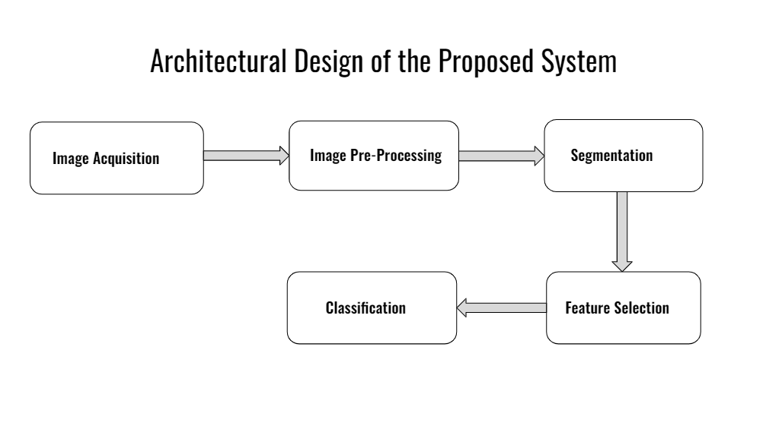

**Figure 4.1:** Architectural Design

**CHAPTER – 5**

**DATASET/ DATABASE SPECIFICATION**

The main characteristics of the training and testing datasets employed in this study encompass the following:

* Both the training and testing datasets consist of 2152 high-quality, real-life symptom images depicting various potato diseases.
* The images in the dataset are classified into three distinct groups: Early blight, Late blight, and healthy.
* Potato Early blight is attributed to the fungus Alternaria solani and manifests symptoms like leaf spots and discoloration.
* Potato Late blight is induced by the oomycete pathogen Phytophthora infectants and can infect potato foliage and tubers at any stage of crop development. This disease can have devastating effects on crop yields.
* The Potato healthy group represents images of healthy potato leaves that are free from any disease.
* The training set was used to train the machine learning model, while the testing set was utilized to evaluate the model's accuracy.
* The inclusion of high-quality images in the dataset is crucial for ensuring precise and dependable disease diagnosis.
* By training the machine learning model on a diverse set of images, we can improve its ability to accurately identify different types of potato disease.

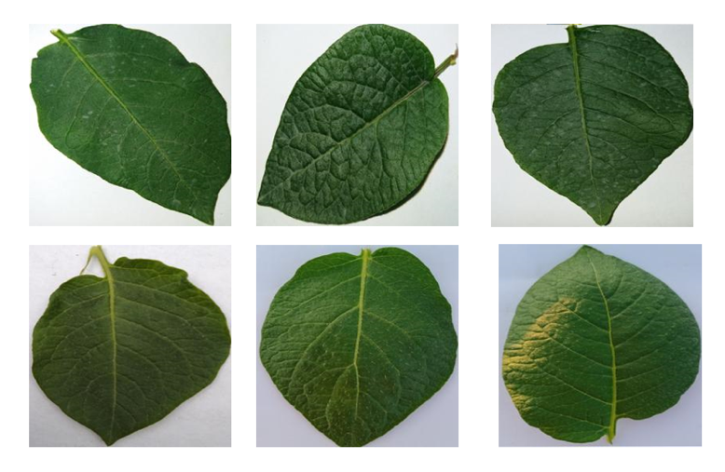

**Figure 5.1:** Images depicting Healthy Potato

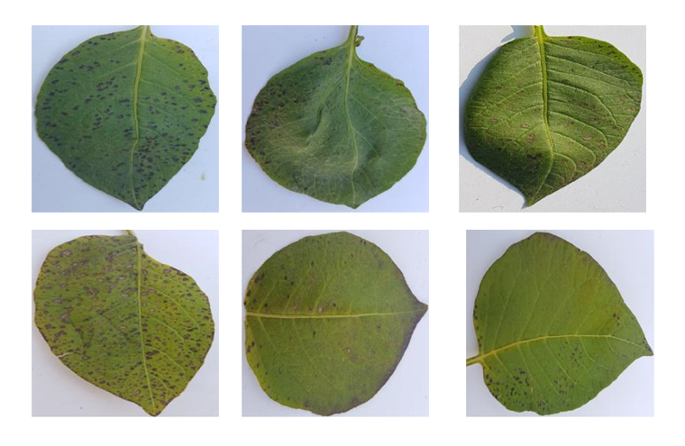

**Figure 5.2:** Images depicting Early blight Potato.

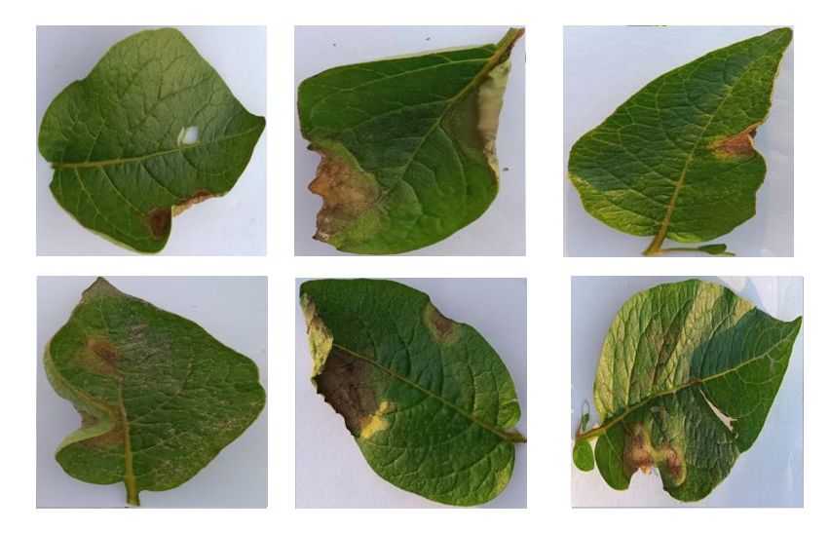

**Figure 5.3:** Images depicting Late blight Potato.

**CHAPTER – 6**

**METHODOLOGY**

The technology used are: -

1. **Machine Learning:**
   * Machine learning, a field of artificial intelligence, utilizes algorithms to analyze and extract knowledge from data.
   * It empowers software applications to make accurate predictions without explicit programming.
   * Machine learning algorithms leverage past data as input to generate new output values.
   * It enables businesses to uncover patterns in customer behavior and operational trends, facilitating the creation of innovative products.
   * Prominent companies such as Facebook, Google, and Uber integrate machine learning extensively into their operations to gain a competitive edge.

In summary, machine learning is a vital tool for businesses looking to stay ahead of the competition. By analyzing data and generating accurate predictions, it allows companies to develop new products, track customer behavior, and gain valuable insights into operational patterns. The technology’s potential for making sense of big data has made it an essential tool for businesses across various sectors, and it is expected to continue growing in importance in the years ahead.

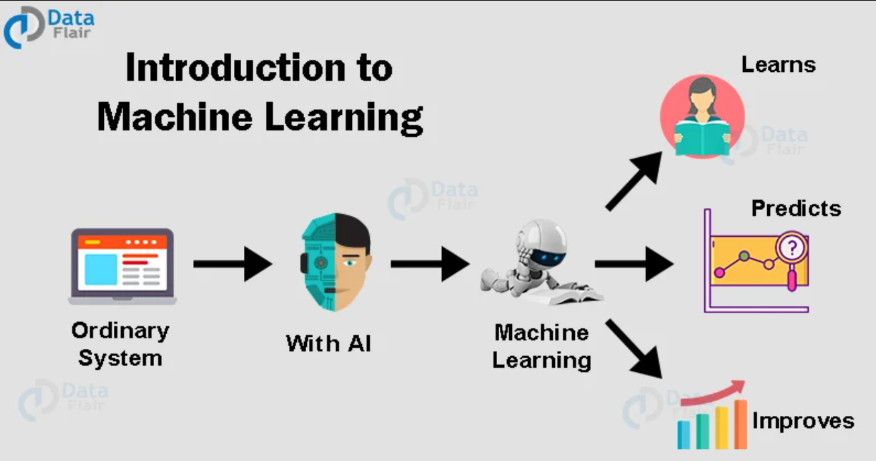

**Figure 6.1:** Machine Learning

**2. Deep Learning:**

* Deep learning is a branch of machine learning that leverages neural networks to extract insights from data and generate accurate predictions.
* It draws inspiration from the structure and functionality of the human brain, featuring interconnected nodes organized into multiple layers for information processing.
* Deep learning models undergo training on extensive datasets, and their accuracy improves with the volume of training data.
* It finds applications in various fields, including speech recognition, computer vision, and natural language processing.
* Deep learning has led to remarkable advancements in areas such as autonomous vehicles, speech recognition, language translation and image recognition.
* Effective training of deep learning models necessitates substantial computational power and data, which can pose challenges for smaller organizations.

In summary, deep learning harnesses the power of neural networks to learn from data and make predictions. It has brought about revolutionary changes in fields like computer vision and natural language processing, holding the potential to transform numerous industries. Nonetheless, the effective training of deep learning models demands substantial computational resources and data, which can pose challenges for certain organizations.

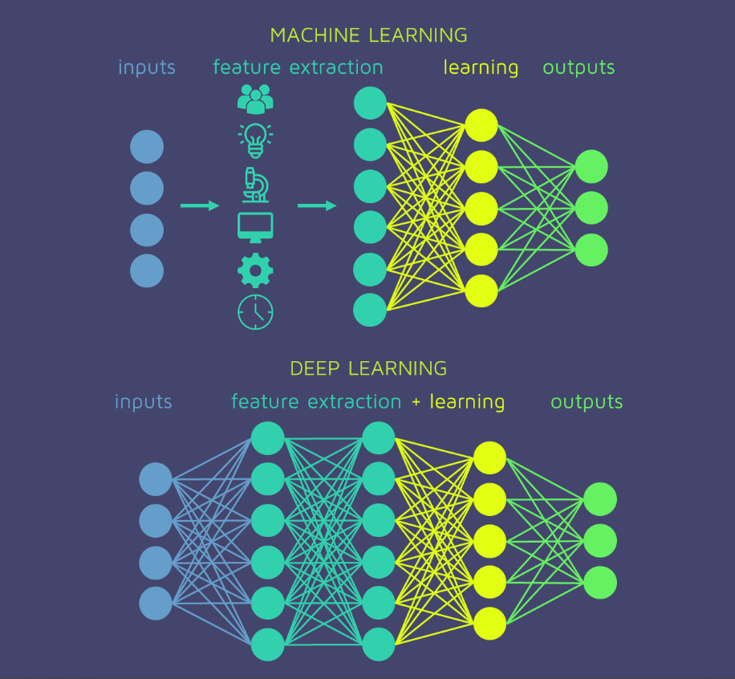

**Figure 6.2:** Deep Learning

**3. Convolutional Neural Network (CNN):**

* Convolutional Neural Networks (CNNs) are a type of deep neural networks that are specifically designed for tasks that involve image and video recognition.
* CNNs draw inspiration from the structural organization of the human brain's visual cortex, utilizing filters that extract image features at various scales and orientations.
* CNNs employ a technique called convolution, where a filter slides across an image and multiplies its values with the corresponding pixel values in the image.
* CNNs can learn to recognize complex patterns in images and classify them into different categories.
* They have been used in applications such as self-driving cars, facial recognition, and medical imaging.
* Training a CNN requires a large dataset of labelled images, which can be a challenge for some applications.

In summary, Convolutional Neural Networks (CNNs) are deep neural networks specifically developed for image and video recognition tasks. They draw inspiration from the human visual cortex's structure and utilize convolution to extract features from images. CNNs are powerful tools for recognizing complex patterns in images and have applications in fields like self-driving cars and medical imaging. However, they require a large dataset of labelled images to be trained effectively, which can be a challenge for some applications.

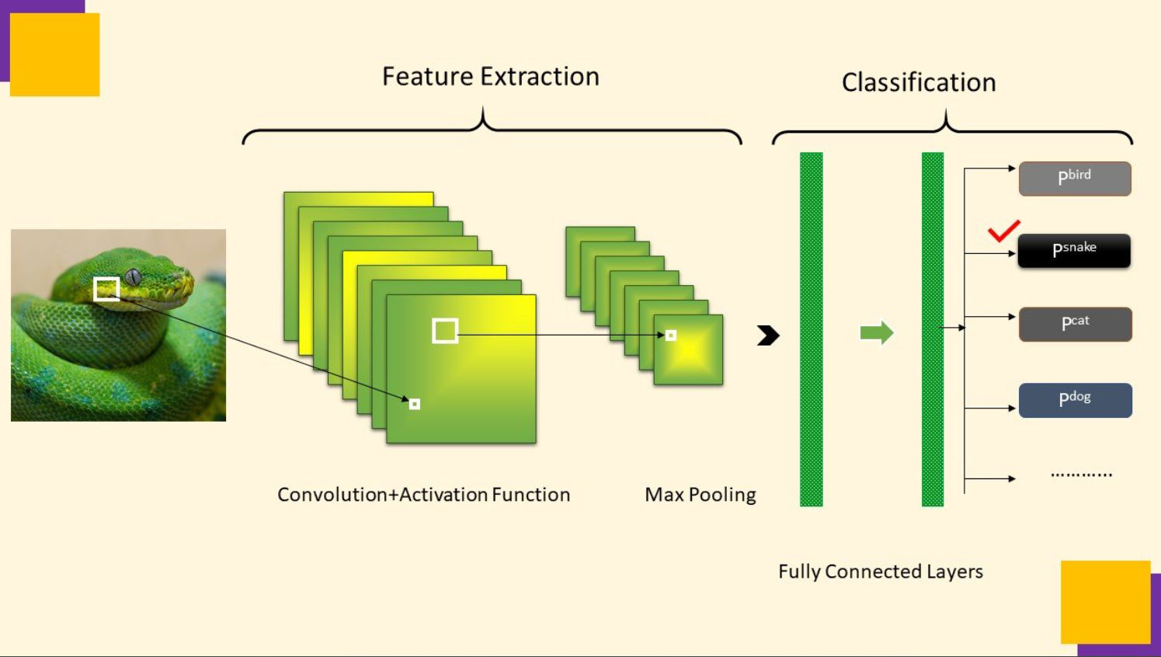

**Figure 6.3:** Convolutional Neural Network

**4. Sequential Model:**

* Sequential models represent a class of neural networks primarily employed for processing sequential data, including time series and natural language.
* They consist of interconnected layers of nodes that sequentially process input data.
* A common example of a sequential model is the Recurrent Neural Network, which incorporates a "memory" to process inputs in relation to previous inputs.
* Another variant is the Long Short-Term Memory network, designed to address the issue of vanishing gradients that may arise in RNNs.
* Sequential models find utility in domains like speech recognition, text generation, and sentiment analysis.
* Training a sequential model necessitates a substantial dataset of labelled sequential data, which can pose challenges for certain applications.

In summary, Sequential Models are neural networks specifically designed for processing sequential data. They find applications in domains like speech recognition and natural language processing. RNNs and LSTMs are two notable types of sequential models that excel at handling sequential data. However, training sequential models requires a large dataset of labelled sequential data, which can be a challenge for some applications.

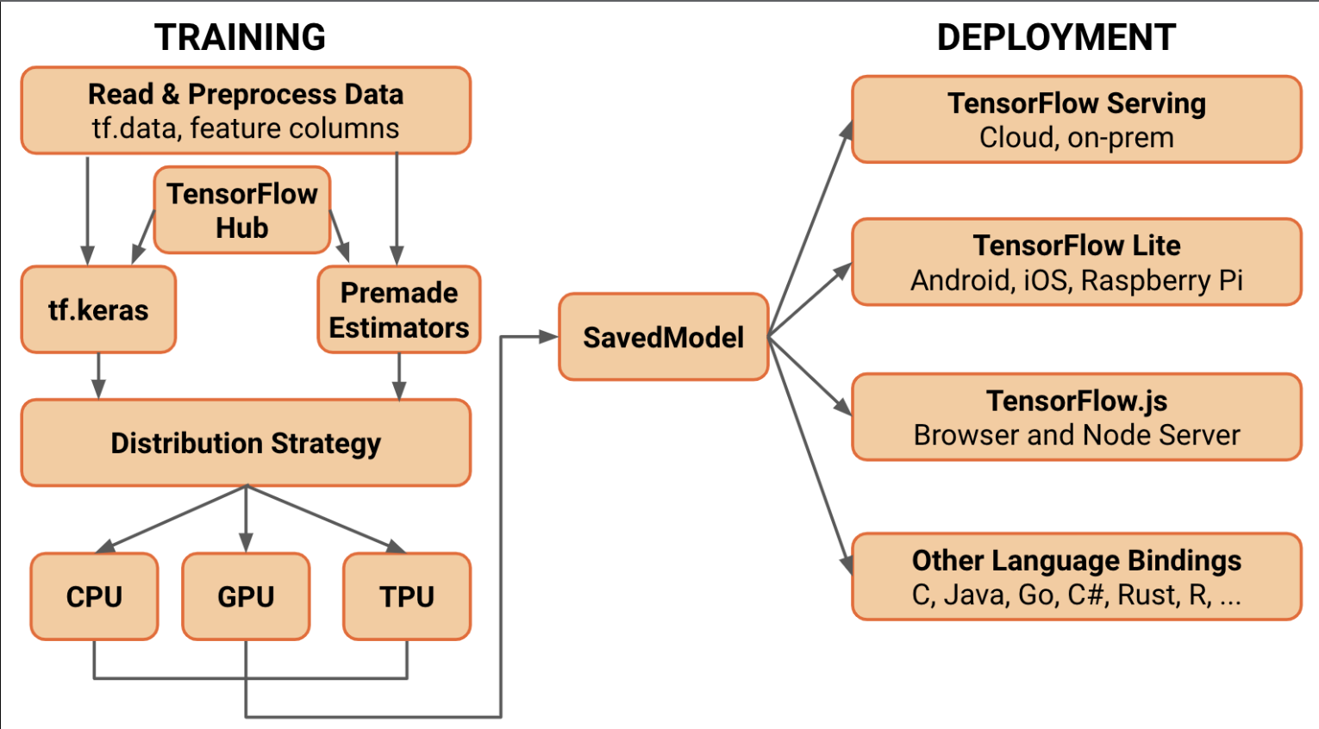

**Figure 6.4:** Sequential Model

**5. TensorFlow:**

* TensorFlow is a freely available software library used for constructing and training machine learning models. It is an open-source framework.
* Created by Google, TensorFlow is widely recognized as one of the most extensively utilized machine learning library.
* It provides a wide range of tools for building neural networks and other ma- chine learning models, including tools for data pre-processing, model building, and model evaluation.
* TensorFlow supports a wide range of platforms, including CPUs, GPUs, and mobile devices.
* It allows users to build models using a high-level interface (such as Keras) or a low-level interface for maximum flexibility and control.
* TensorFlow finds applications in various domains, including predictive analytics, natural language processing, and image and speech recognition.

In summary, TensorFlow is a renowned machine learning library extensively employed for constructing machine learning models. It offers a comprehensive set of tools for model development and evaluation, supporting various platforms. It enjoys widespread adoption in both research and industry, playing a pivotal role in driving numerous recent advancements in machine learning.

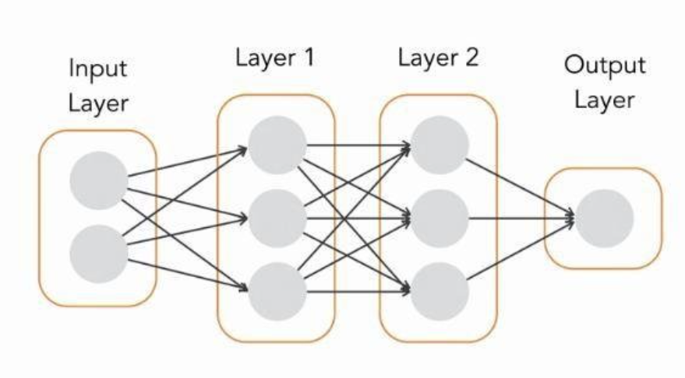

**Figure 6.5:** TensorFlow

**6. Image processing:** Image Processing is the use of algorithms to transform and analyze images. Image processing encompasses a diverse range of techniques, each with distinct applications and benefits.

Here are five main types of image processing:

* **Visualization**: Visualization techniques are used to enhance the visual appearance of images to improve human perception. This includes techniques like contrast stretching, histogram equalization, and color mapping.
* **Recognition**: Recognition techniques are used to identify objects or features in an image. These techniques encompass various aspects such as facial detection, optical character recognition (OCR) and object detection.
* **Sharpening** **and** **Restoration**: Sharpening and restoration techniques are used to improve the quality of images that are degraded by noise or other factors. This includes techniques like noise reduction, deblurring, and super- resolution.
* **Pattern** **Recognition**: Pattern recognition techniques are used to identify pat- terns or textures in an image. This includes techniques like texture analysis, edge detection, and feature extraction.
* **Retrieval**: Retrieval techniques play a crucial role in searching for images that exhibit similarity to a given image or set of images. These techniques include content-based image retrieval (CBIR) and image classification.

In summary, Image Processing is a broad field with many different types of techniques used to transform and analyze images. The five main types include visualization, recognition, sharpening and restoration, pattern recognition, and retrieval. Each type of image processing technique possesses its own distinct applications and methods, finding utility in diverse fields such as medicine, manufacturing, and security.

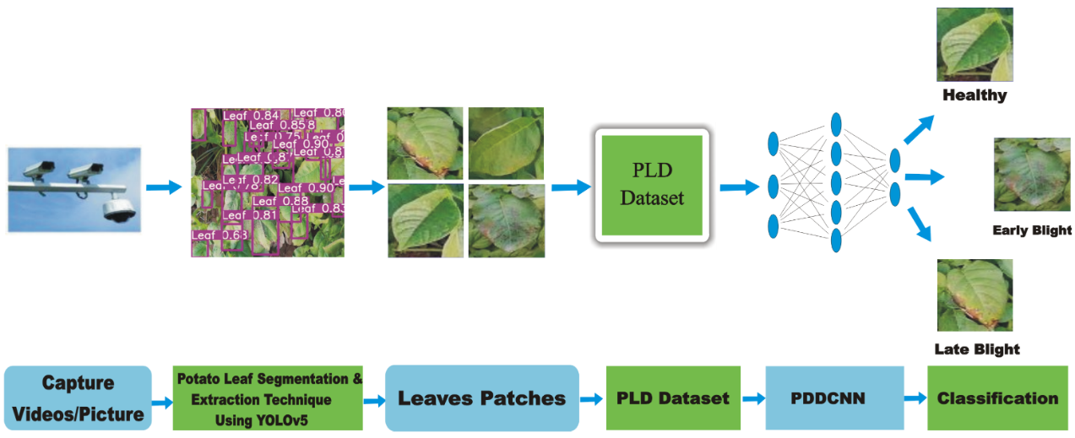

**Figure 6.6:** Image processing

**7. ReactJS:** ReactJS is a well-known JavaScript library that is widely used for developing user interfaces in an open-source manner. Originally developed by Facebook, ReactJS is now embraced by numerous companies, regardless of their size. It empowers developers to create intricate and interactive user interfaces effortlessly. ReactJS simplifies the process of state management within web applications, facilitating efficient development practices.

Some key features of ReactJS includes:

* **Component-Based Architecture:** ReactJS revolves around the concept of decomposing an application into reusable and modular components. This approach simplifies the development and maintenance of intricate user interfaces, allowing for efficient construction and management.
* **Virtual DOM:** To enhance performance and minimize the need for excessive updates during rendering, ReactJS employs a virtual representation of the Document Object Model (DOM). By utilizing this virtual DOM, ReactJS optimizes the efficiency of rendering changes in the user interface.
* **One-way data binding**: ReactJS follows a unidirectional data flow, which implies that modifications made in the user interface do not directly impact the application state. This unidirectional flow simplifies the management of complex state changes, enhancing the overall control and predictability of the application's behavior.
* **JSX**: ReactJS utilizes JSX, a syntax that enables developers to write HTML-like code within JavaScript. This integration of HTML-like syntax with JavaScript facilitates a more comprehensible and manageable structure for web applications, streamlining the development process.

In summary, ReactJS is a popular JavaScript library for building interactive user interfaces. Its component-based architecture and efficient handling of the virtual DOM make it a powerful tool for creating complex web applications. It has a large and active community and is often used in combination with other technologies to build web and mobile applications.

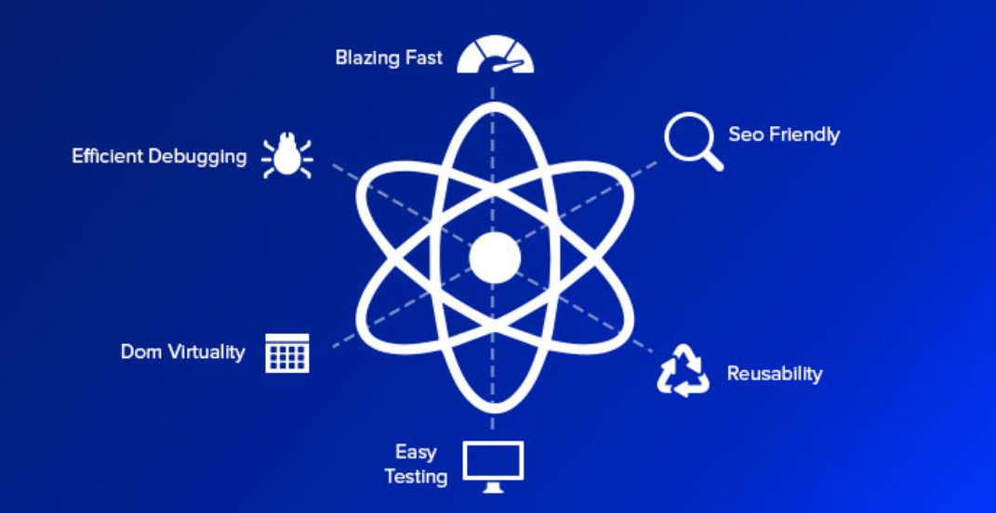

**Figure 6.7:** ReactJS

**CHAPTER – 7**

**FINAL** **IMPLEMENTATION**

**7.0.1 Code** **Snippets**

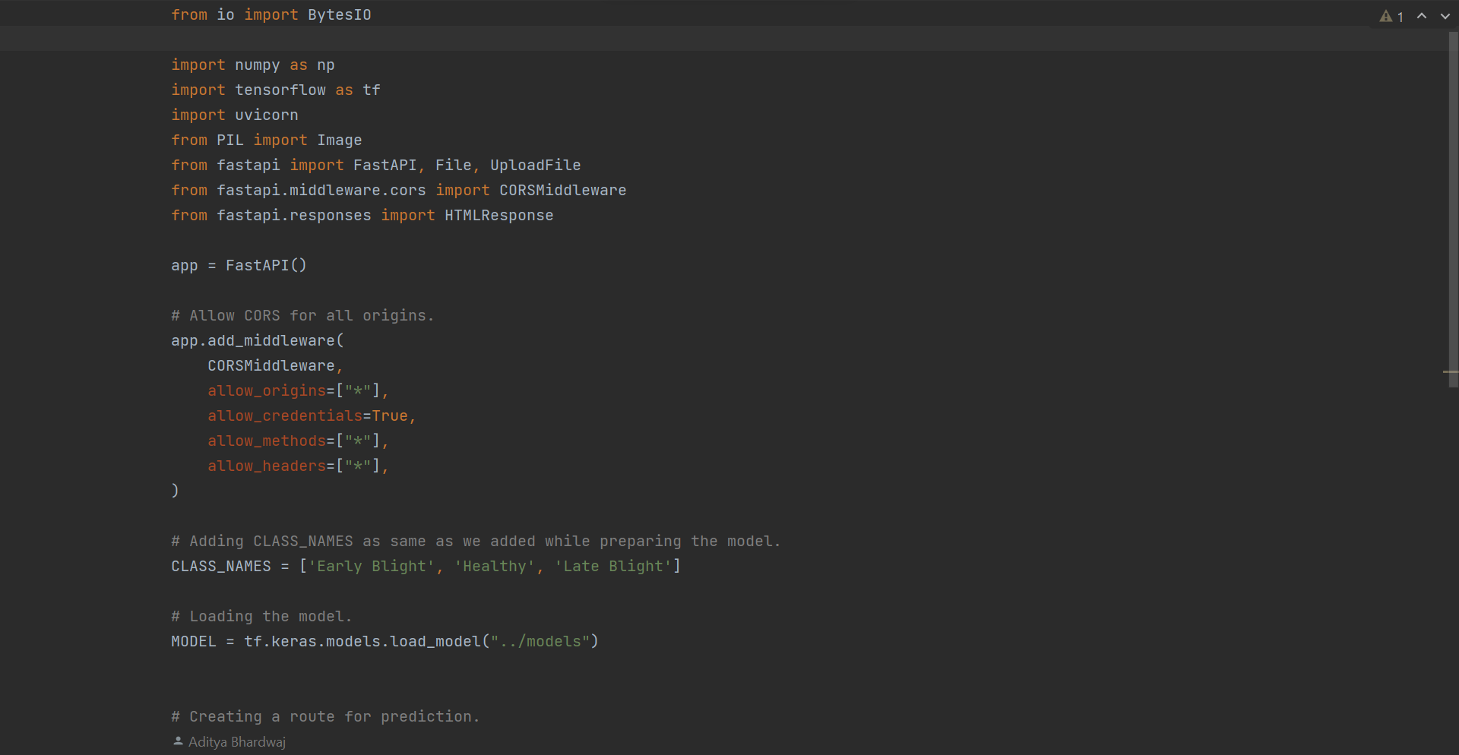

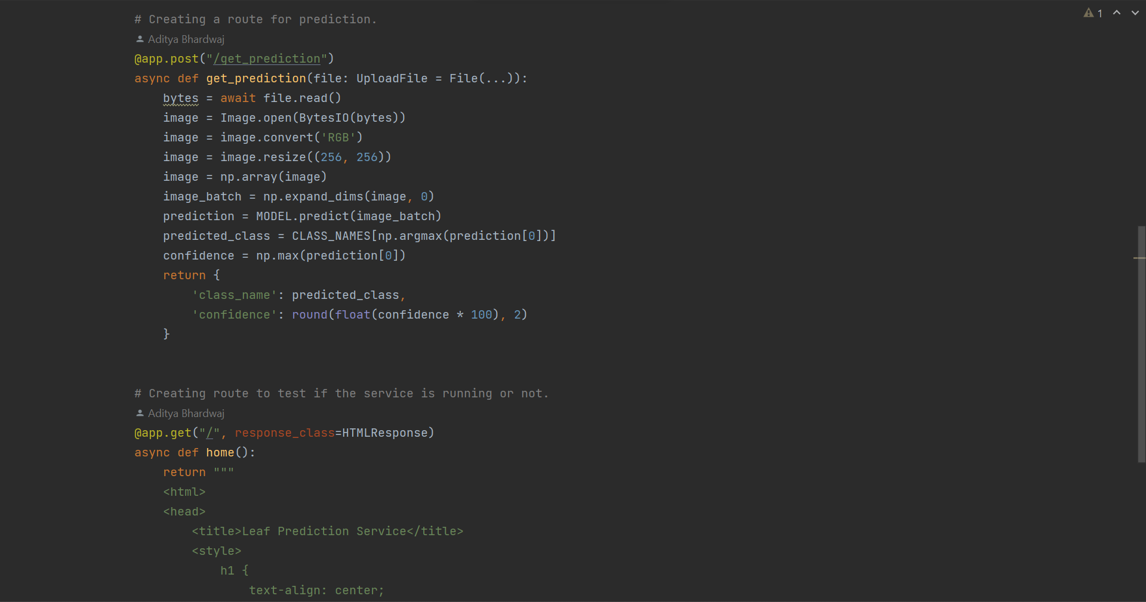

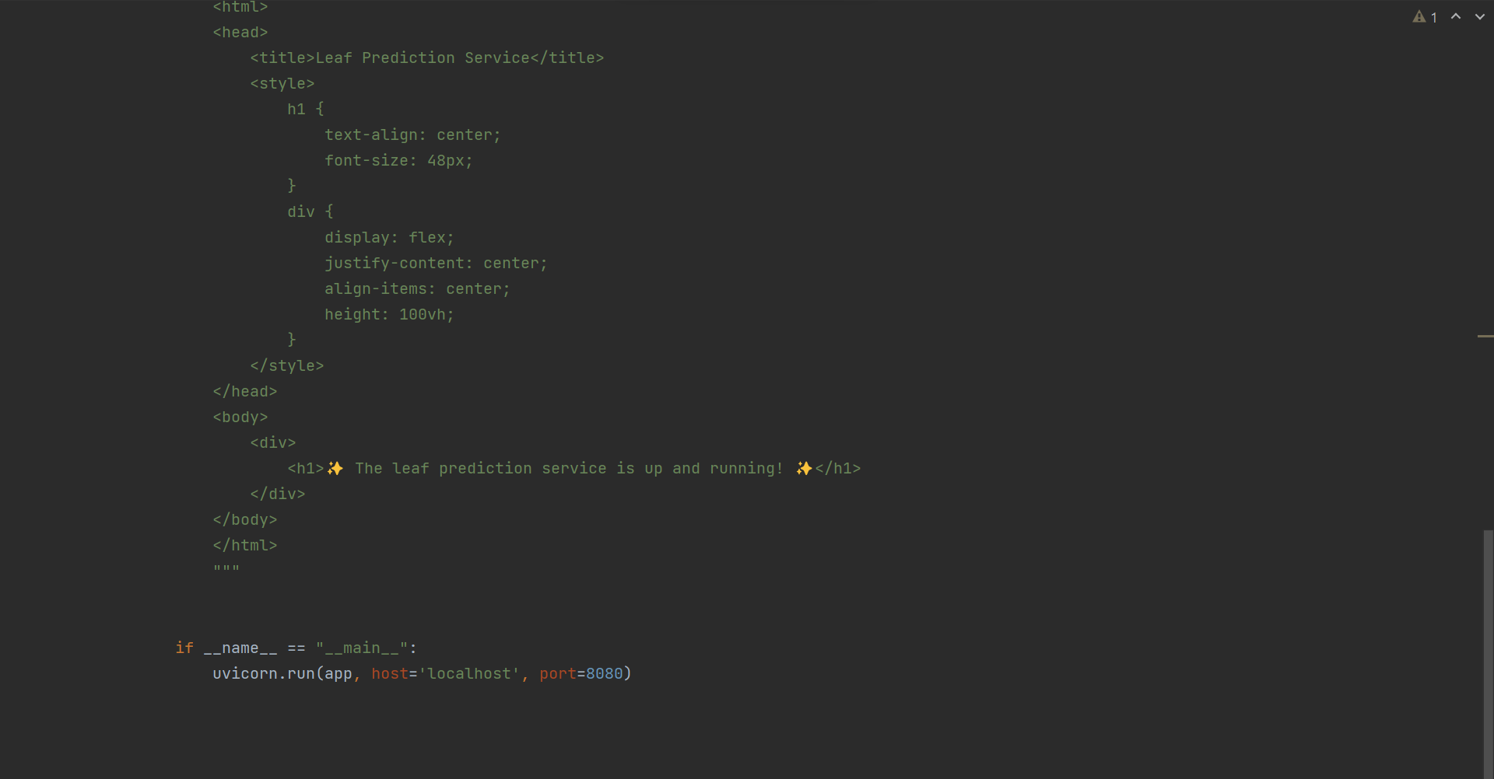

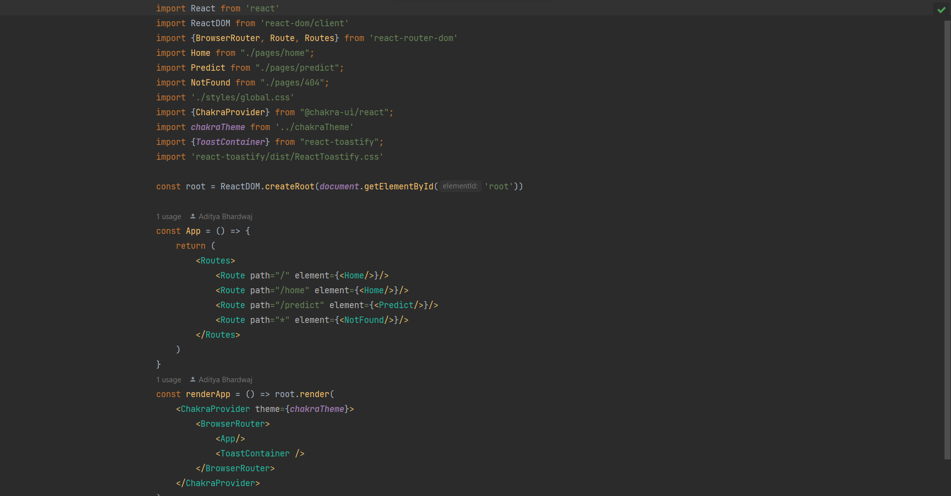

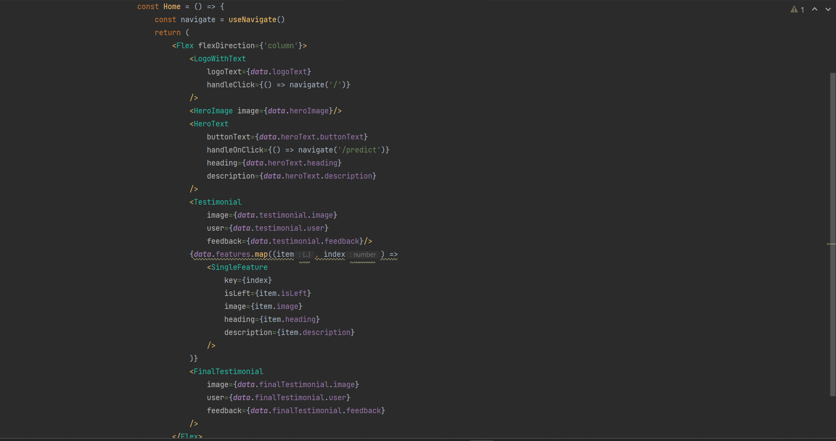

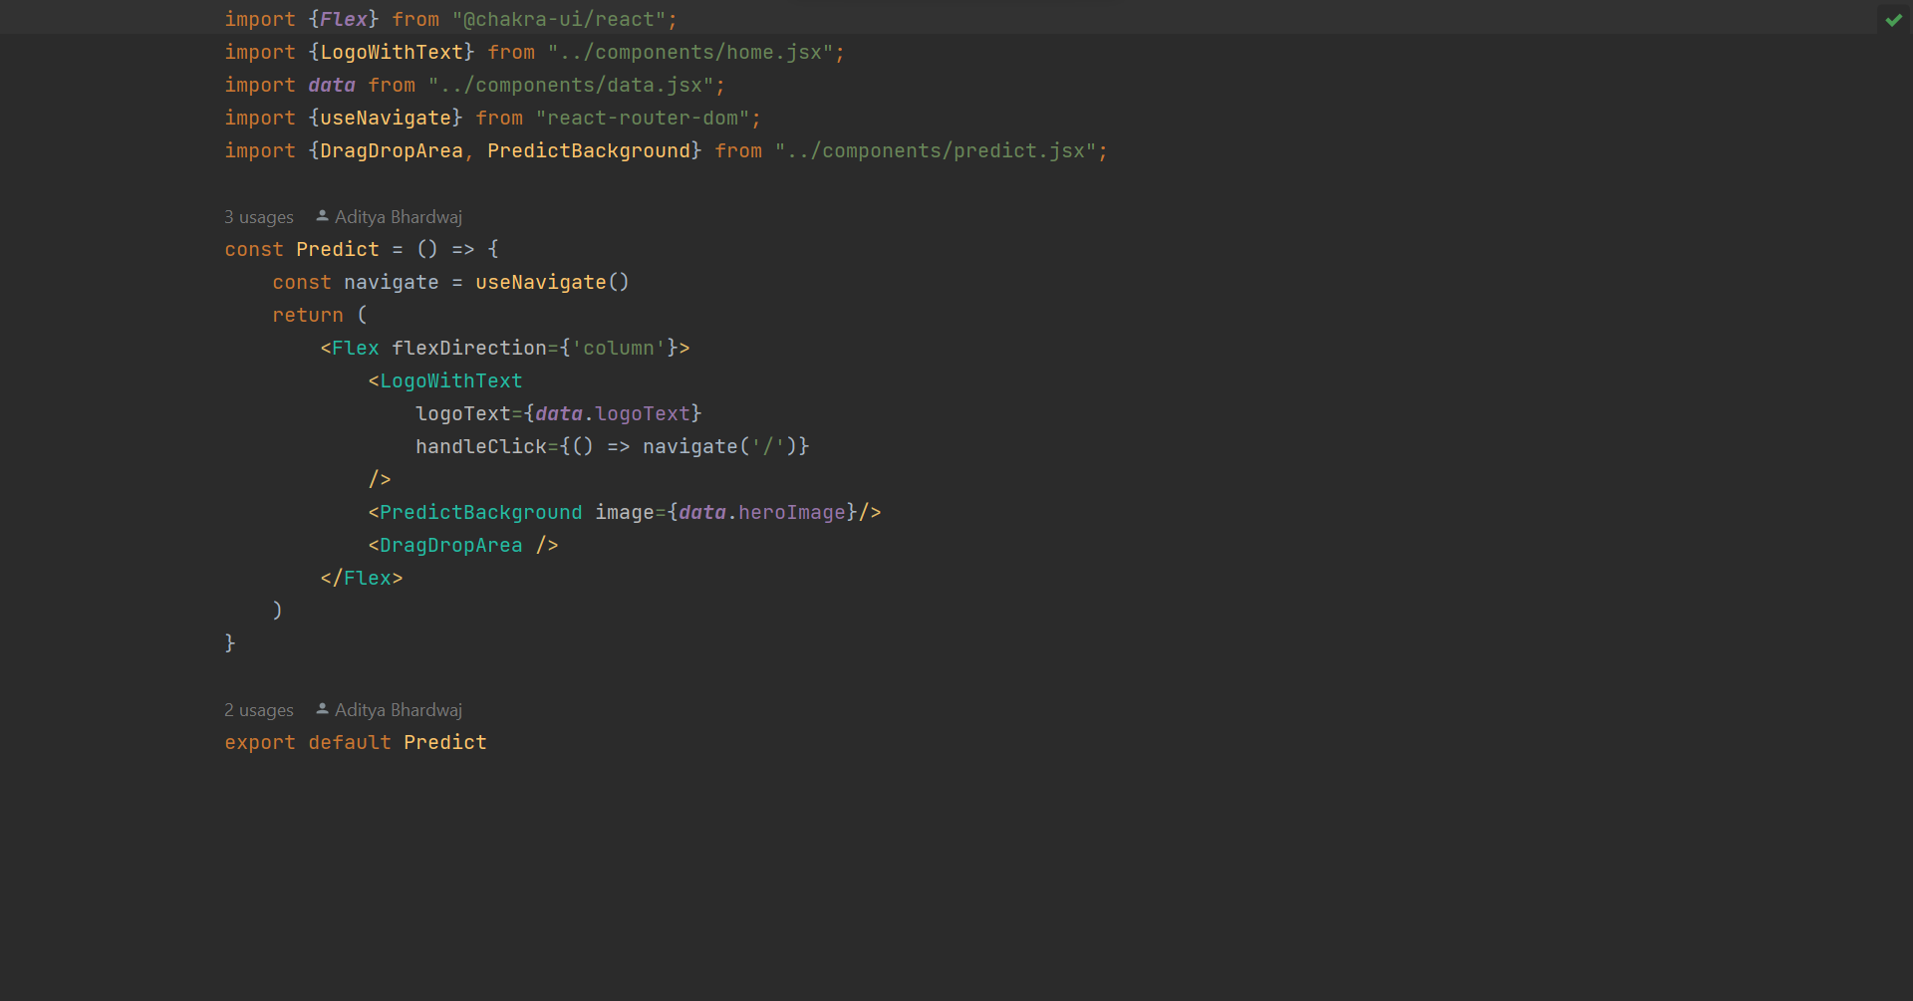

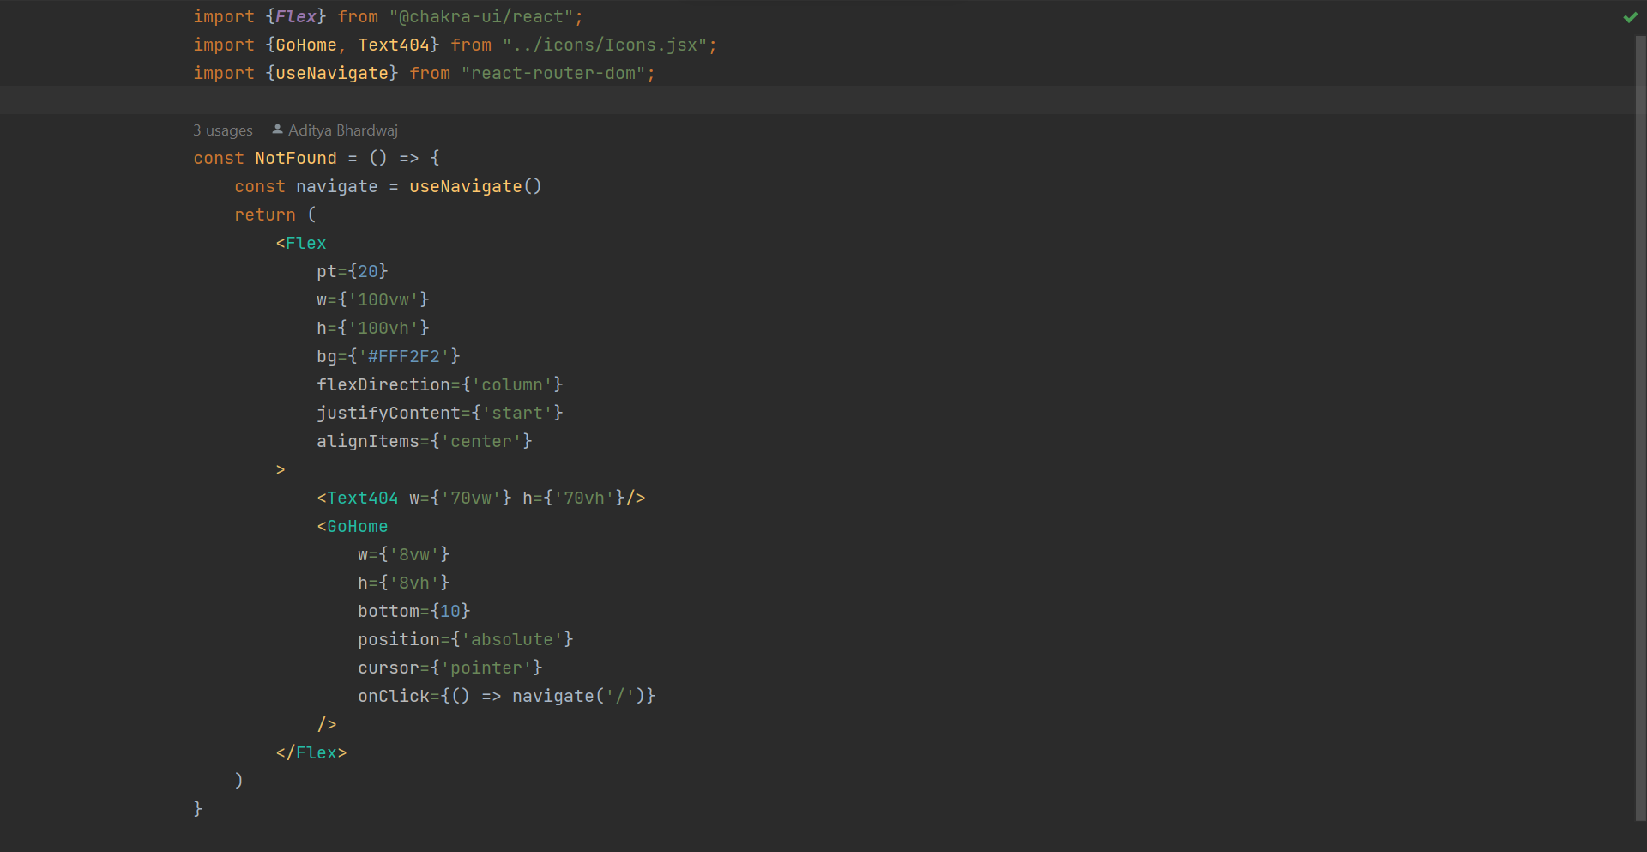

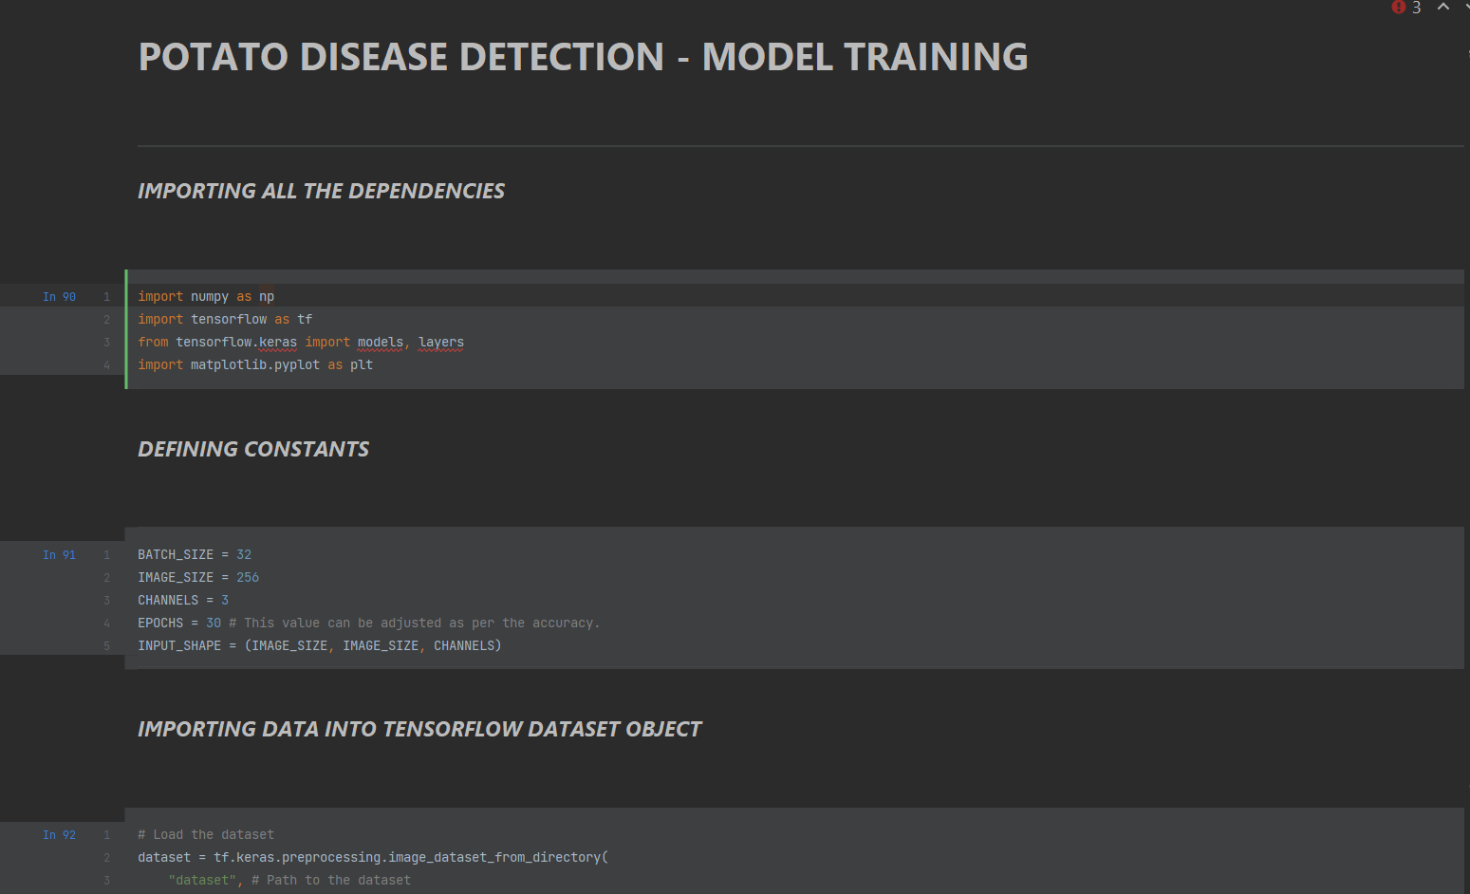

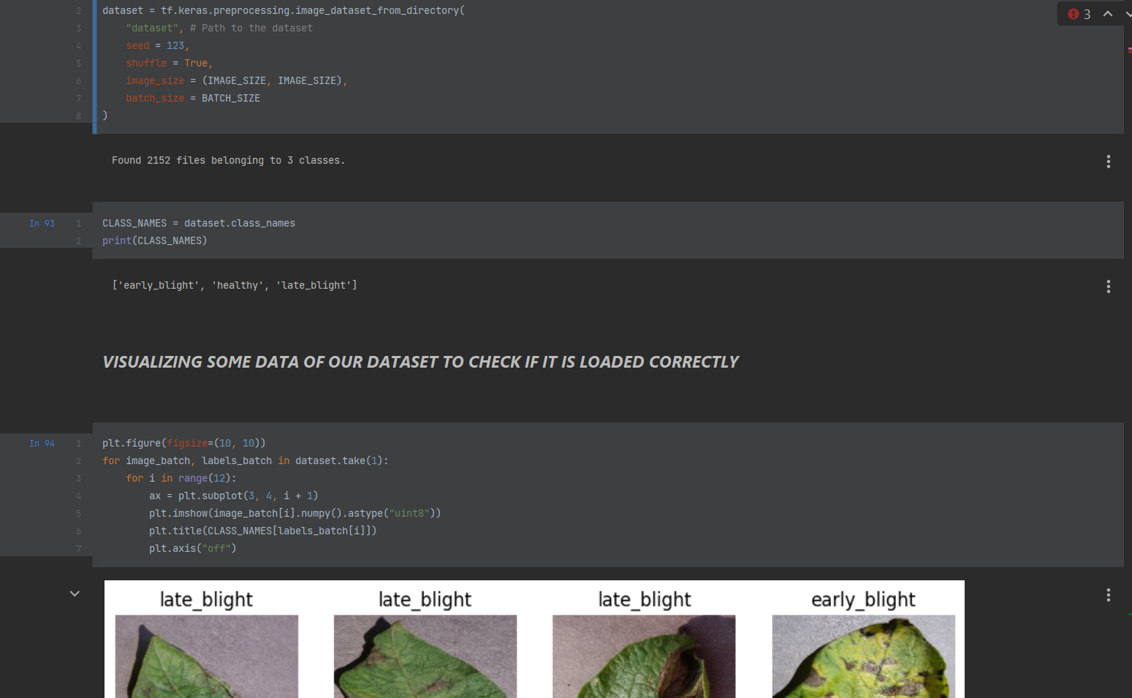

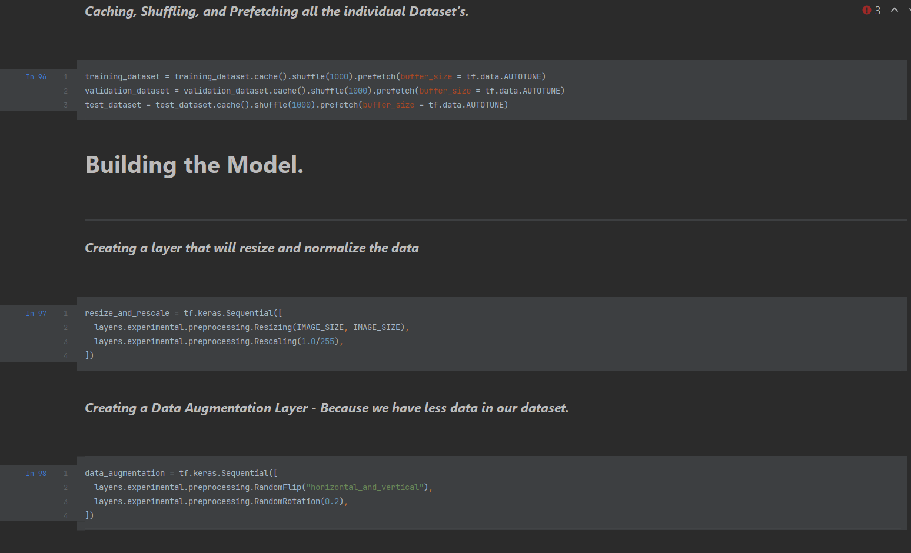

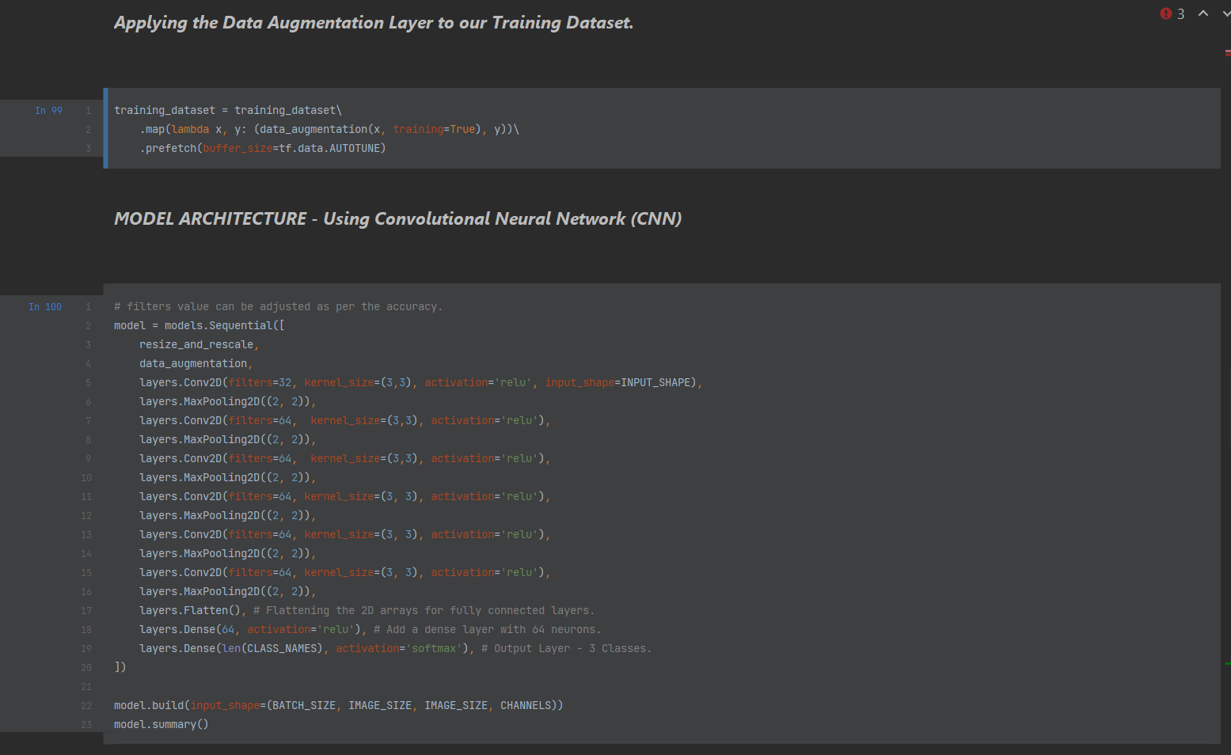

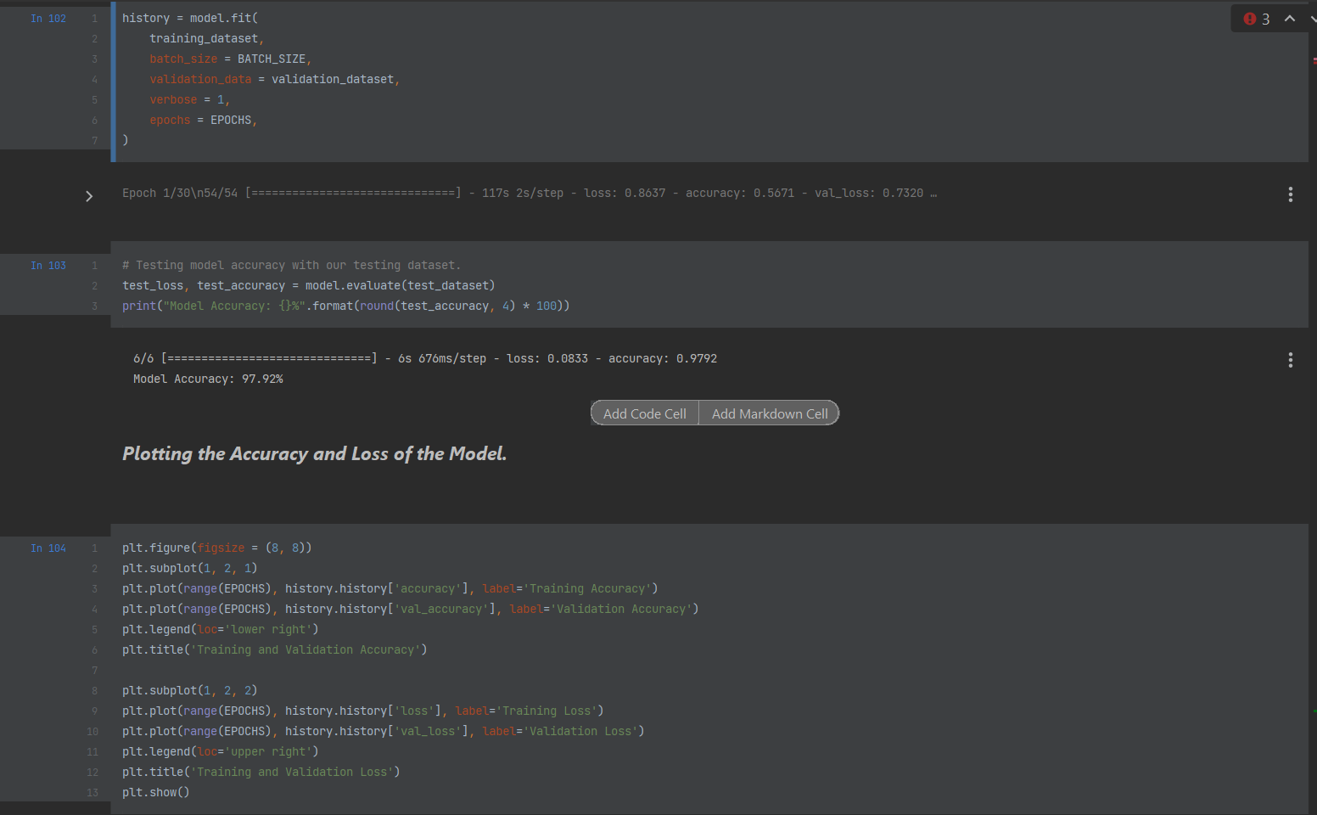

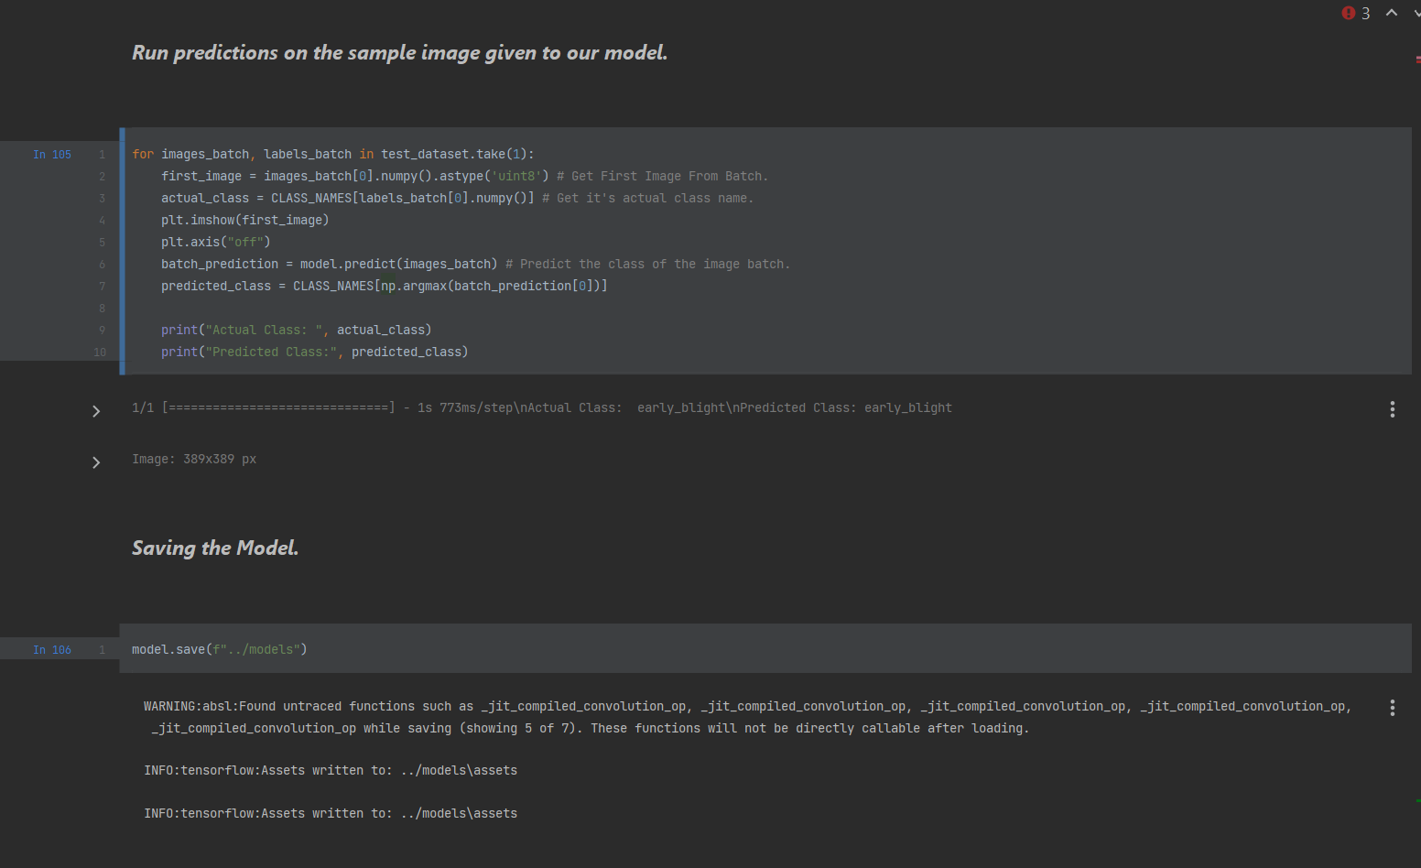

**7.0.2** **Important Links**

Our project, the "**Leaf Predictor**", a web-based application that uses machine learning algorithms to predict the type of plant leaf based on an image provided by the user. We have successfully deployed it using free services available in the market.

To ensure a smooth user experience, we chose to use Cloudflare Pages for the frontend part of our application. Cloudflare Pages is a modern web application hosting platform that allows developers to deploy static sites with ease. This platform has the advantage of being highly scalable, meaning that it can handle large amounts of traffic without any issues. With no complications in the deployment process.

Our frontend site is accessible via the link: [**https://leaf-predictor.pages.dev**](https://leaf-predictor.pages.dev)

For the backend part of our application, we turned to Render.com, a cloud-based plat- form that makes it easy to deploy and scale applications. We deployed our backend using Render, which offers a highly secure and reliable hosting environment for our application. The smooth functioning of our application relies heavily on the stability of the backend, and Render.com provides exactly that.

The backend is accessible via the link: [**https://leaf-predictor.onrender.com**](https://leaf-predictor.onrender.com)

By leveraging these free services, we have been able to deploy our application without any significant obstacles. Our goal is to provide our application to a larger audience, enabling more people to benefit from our project.

The code can be accessed via the link: [**https://github.com/aditya-190/predictor**](https://github.com/aditya-190/predictor)

We hope that our project will be of great value to users and contribute to the field of plant leaf classification.

**CHAPTER – 8**

**EXPECTED** **OUTCOME**

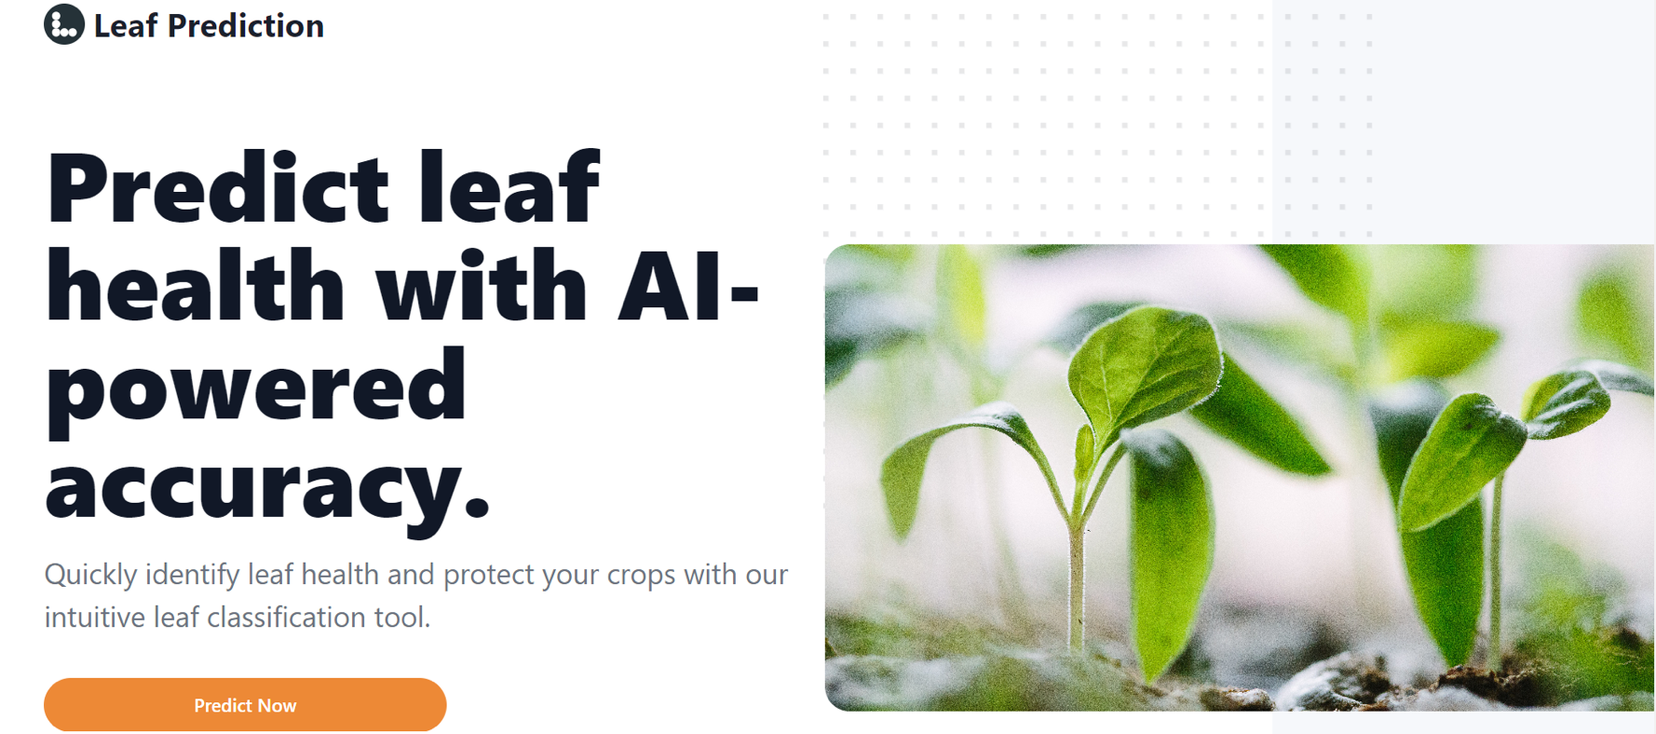

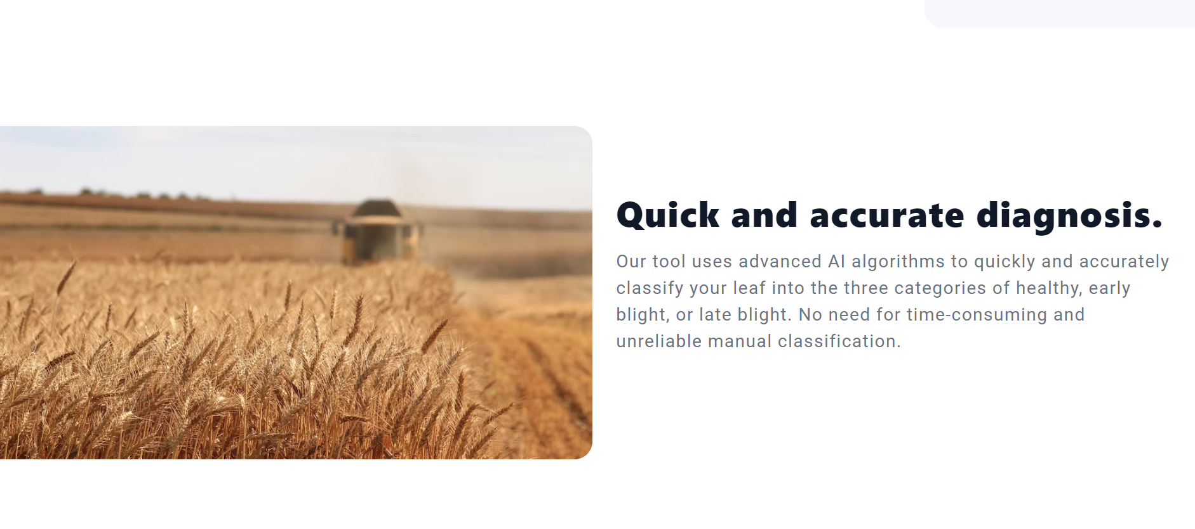

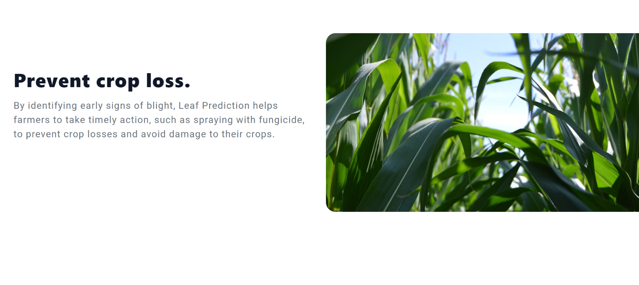

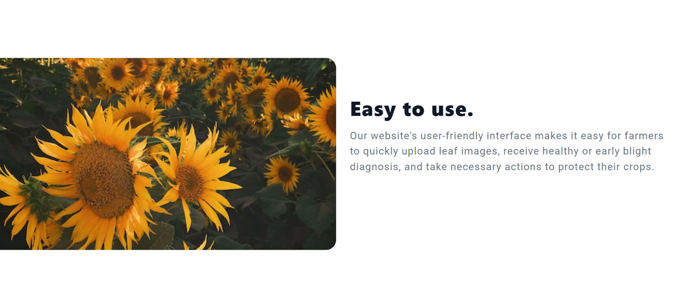

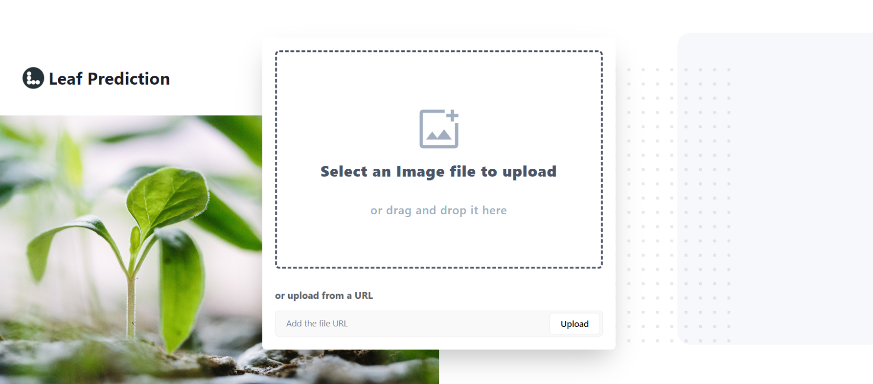

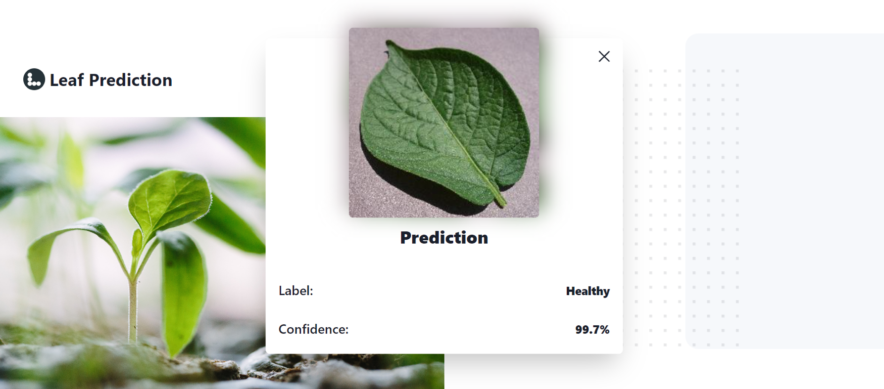

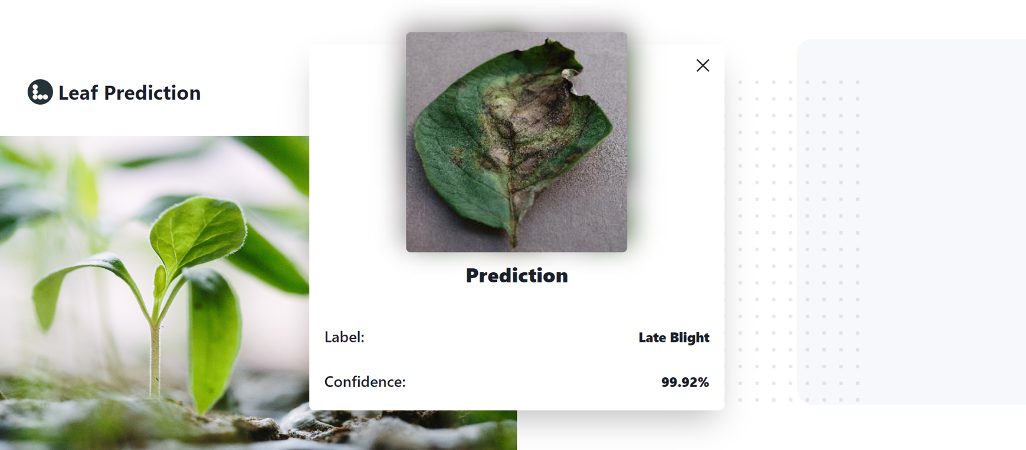

**CHAPTER – 9**

**CONCLUSION**

In conclusion, the utilization of machine learning techniques, including Convolutional Neural Networks (CNN), Keras, Sequential Models and Tensorflow, has demonstrated effectiveness in plant disease diagnosis. This study specifically focused on processing and segmenting images of potato leaves infected with Early Blight, Late Blight, and healthy potato. The results showed a significant improvement in accuracy, from 90% to 95%, which indicates that the method is reliable for diagnosing plant diseases.

However, it is crucial to recognize that this approach requires investigation to address these challenges with this approach. One such limitation is the requirement for extensive labelled data to effectively train the model. Another limitation is the difficulty of distinguishing between different types of diseases that may have similar symptoms.

Despite these limitations, the potential of machine learning for plant disease diagnosis is significant. By combining advanced imaging technology with machine learning algorithms, we can accurately diagnose diseases early, leading to improved crop yield and reduced economic losses. In summary, this study provides a notable contribution to plant disease diagnosis, highlighting the importance of future investigations in this area.

**CHAPTER – 10**

**FUTURE WORK**

Moving forward, there are several opportunities for further development and improvement of the current approach to plant disease diagnosis using machine learning techniques. One possibility is to extend the scope of the project to include other crops and plant species. This would require the collection of more extensive data sets and the implementation of additional processing and segmentation techniques specific to the new plant species.

Additionally, further research could be conducted to extract additional features from the images. By analyzing additional features, we may be able to in- crease the accuracy of our model even further, and potentially detect diseases in their early stages.

Furthermore, the results of this study could be used to develop an app interface that can be used by farmers to diagnose plant diseases quickly and easily. The application has the potential to leverage the machine learning model developed in this study, enabling real-time disease diagnosis for farmers directly in the field. By making this technology accessible to farmers worldwide, we can potentially reduce the impact of plant diseases on crop yields and increase food security.

In conclusion, the possibilities for further development and improvement of plant dis- ease diagnosis using machine learning techniques are numerous. With additional research and development, we can improve the accuracy and usability of this technology, and ultimately help farmers around the world to more effectively combat plant diseases and increase their crop yields.

**CHAPTER – 11**

**REFERENCES**

Peng Jiang, Yuehan Chen, Bin Liu, Dongjian He, Chunquan Liang,’ Real-Time Detection of Apple Leaf Diseases Using Deep Learning Approach Based on Improved Convolutional Neural Networks’, (Volume: 7), pp. 06 May 2019

Zhou, R., Kaneko, S., Tanaka, F., Kayamori, M., Shimizu, M., ‘Disease detection of Cercospora Leaf Spot in sugar beet by robust template matching’, Computers and Electronics in Agriculture, Volume 108, pp.58-70, 2014

Barbedo, J.G.A., Godoy, C.V., ‘Automatic Classification of Soybean Diseases Based on Digital Images of Leaf Symptoms’, SBI AGRO, 2015

Bashish, D.A., Braik, M., Ahmad, S.B., ‘A Framework for Detection and Classification of Plant Leaf and Stem Diseases’, International Conference on Signal and Image Processing, pp. 113-118, 2010

Punajari, J.D., Yakkundimath, R., Byadgi, A.S., ‘Image Processing Based Detection of Fungal Diseases in Plants’, International Conference on Information and Communication Technologies, Volume 46, pp. 1802-1808, 2015.

Zulkifli Bin Husin, Abdul Hallis Bin Abdul Aziz, Ali Yeon Bin Md Shakaff Rohani Binti S Mohamed Farook, “Feasibility Study on Plant Chili Disease Detection Using Image Processing Techniques”, 2012 Third International Conference on Intelligent Systems Modelling and Simulation

Chunxia Zhang, Xiuqing Wang, Xudong Li, “Design of Monitoring and Control Plant Disease System Based on DSPFPGA”, 2010 Second International Conference on Net- worksSecurity, Wireless Communications and Trusted Computing.